- HOME

- HOW TO FEED TURMERIC TO DOGS

HOW TO FEED TURMERIC TO DOGS
Turmeric benefits your dog in many different ways:
- It can decrease inflammation (can help with itchy skin issues)
- It’s a powerful antioxidant
- It's an anticoagulant (lowering the risk of blood clots)
PLUS there is a range of other benefits when feeding turmeric for dogs – we suggest you read Why Turmeric for Animals if you’re curious to learn more.
It’s up to you HOW you choose to feed turmeric to your dog. Essentially you need to make sure you are adding the 3 Basic Ingredients to help with the absorption and allow your pet to gain some turmeric benefits.
PLEASE NOTE: Commercial capsules/pills (that have high levels of curcumin- 95%) are NOT RECOMMENDED for use with animals
Below are 4 ways to feed turmeric for dogs with method one being the No.1 way for maximum absorption and benefits….

Method One – create Golden Paste
Create some Golden Paste and add it to your dog’s diet as often as possible. Smaller portions work best.
Cooking the turmeric in water helps to make it more digestible by softening the starches and beginning the digestive process. It also makes the curcumin in turmeric slightly more water soluble than it is without being cooked. Those of us who have tried turmeric both cooked and uncooked have seen a significant difference in the amount of benefit for the same amount of turmeric.
Some dogs will lick the paste off a spoon but others like it in a soup or gravy with their feed. Some need the paste syringed into their mouths. All are different and the Turmeric User Group (TUG) on Facebook will have the answer to your dilemma if you have a turmeric diva!

Method Two – make a simple Gravy
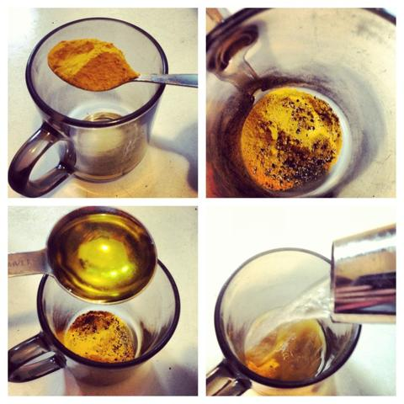
This is a less desirable way to feed turmeric, but might be helpful in situations where you only have a small amount of turmeric available to you, or don't have a stove where you can cook a batch of golden paste. Or perhaps you don't have refrigeration for a whole batch and need to make just enough for a couple of meals at at time.
Put a teaspoon (or smaller) of turmeric powder in a heat-safe cup (like a measuring cup), add boiling water until the cup is 1/3 full and then let it cool for a few minutes. Add about 1/8 tsp of freshly cracked pepper and about a teaspoon of any healthy oil (such as coconut, olive or linseed). This will make roughly one half cup of 'gravy,' more than enough for one day's use.
Add some of the mix as a gravy to your dog’s food bowl and let it soak in. Watch as they gobble it down and get turmeric stains on their whiskers :).

Method Three – just add the Ingredients
This is the least desirable way to feed turmeric, but if you don't have access to any way to cook the turmeric, it may be your only choice.
Add 1/4 tsp turmeric powder, 1/4 tsp of a healthy oil (such as coconut, olive or linseed) and a few grinds of black pepper to the dog's food. This is not only the least beneficial way to serve turmeric, but also the least convenient, as it requires you to measure out three ingredients every time you want to feed it. But if there is no way for you to make golden paste, and you don't even have access to hot water to make a gravy, this would be one way to provide turmeric to your dog.
Once the dog is used to having 1/4 tsp turmeric at a time, you might need to increase the amount you're feeding in order to produce the best results for the dog. If you do that, remember that the other ingredients must be proportionately increased as well.

Method Four – Use a Commercial Mix or Capsules
We have a range of trusted suppliers around the globe here >> Where to buy Turmeric << that offer good quality turmeric products.
PLEASE NOTE: We do not recommend commercial capsules/pills (that have high levels of curcumin- 95%). These are not turmeric, but just a high-concentrate extract of one of the active constituents of turmeric, the curcuminoids. Curcumin extracts have their place as an add-on to the effective use of whole turmeric, in cases of severe disease. But they are minimally effective by themselves, and have not had sufficient testing for longterm adverse effects in animals.
General directions for feeding
Start small and build up the serving size over a two to three week period. Gradually increase the amount--don't jump from a very small amount to a much larger one. If you are feeding golden paste twice a day, adding a third serving would be better than increasing the amounts of the other two. If the dog does well with the extra serving, but still needs more golden paste, then you could start to increase the amount of the other servings, one at a time.
Little and often through the day is preferable to one large feeding daily, but if you can only manage it twice a day, at least do that much.
Guide lines are just that, it is trial and error to find the right amount for each individual.
When you observe actual pain relief and improvement of movement OR in some cases, a reduction of tumour size, use this as the daily maintenance amount.
Note: Turmeric increases gut motility (the time it takes for food to transit the intestinal system). If there are any signs of loose stools or stomach upset then you may wish to reduce the portion to 1/8 teaspoon or so, and remain at a lower amount for a longer period.

